뷰 템플릿과 레이아웃

[부트스트랩5.0](https://getbootstrap.com/docs/5.0/getting-started/introduction/)을 이용해서 CSS 넣기

**greetings.mustache**

<!doctype html>

<html lang="en">

<head>

<meta charset="utf-8">

<meta name="viewport" content="width=device-width, initial-scale=1">

<link href="https://cdn.jsdelivr.net/npm/bootstrap@5.0.2/dist/css/bootstrap.min.css" rel="stylesheet" integrity="sha384-EVSTQN3/azprG1Anm3QDgpJLIm9Nao0Yz1ztcQTwFspd3yD65VohhpuuCOmLASjC" crossorigin="anonymous">

<title>Hello, world!</title>

</head>

<body>

<nav class="navbar navbar-expand-lg navbar-light bg-light">

<div class="container-fluid">

<a class="navbar-brand" href="#">Navbar</a>

<button class="navbar-toggler" type="button" data-bs-toggle="collapse" data-bs-target="#navbarSupportedContent" aria-controls="navbarSupportedContent" aria-expanded="false" aria-label="Toggle navigation">

<span class="navbar-toggler-icon"></span>

</button>

<div class="collapse navbar-collapse" id="navbarSupportedContent">

<ul class="navbar-nav me-auto mb-2 mb-lg-0">

<li class="nav-item">

<a class="nav-link active" aria-current="page" href="#">Home</a>

</li>

<li class="nav-item">

<a class="nav-link" href="#">Link</a>

</li>

<li class="nav-item dropdown">

<a class="nav-link dropdown-toggle" href="#" id="navbarDropdown" role="button" data-bs-toggle="dropdown" aria-expanded="false">

Dropdown

</a>

<ul class="dropdown-menu" aria-labelledby="navbarDropdown">

<li><a class="dropdown-item" href="#">Action</a></li>

<li><a class="dropdown-item" href="#">Another action</a></li>

<li><hr class="dropdown-divider"></li>

<li><a class="dropdown-item" href="#">Something else here</a></li>

</ul>

</li>

<li class="nav-item">

<a class="nav-link disabled" href="#" tabindex="-1" aria-disabled="true">Disabled</a>

</li>

</ul>

<form class="d-flex">

<input class="form-control me-2" type="search" placeholder="Search" aria-label="Search">

<button class="btn btn-outline-success" type="submit">Search</button>

</form>

</div>

</div>

</nav>

<div class="bg-dark text-white p-5">

<h1>{{username}},님 반갑습니다.</h1>

</div>

<!-- site info -->

<div class="mb-5 container-fluid">

<hr>

<p>ⓒ CloudStudying | <a href="#">Privacy</a> | <a href="#">Terms</a></p>

</div>

<script src="https://cdn.jsdelivr.net/npm/bootstrap@5.0.2/dist/js/bootstrap.bundle.min.js" integrity="sha384-MrcW6ZMFYlzcLA8Nl+NtUVF0sA7MsXsP1UyJoMp4YLEuNSfAP+JcXn/tWtIaxVXM" crossorigin="anonymous"></script>

</body>

</html>

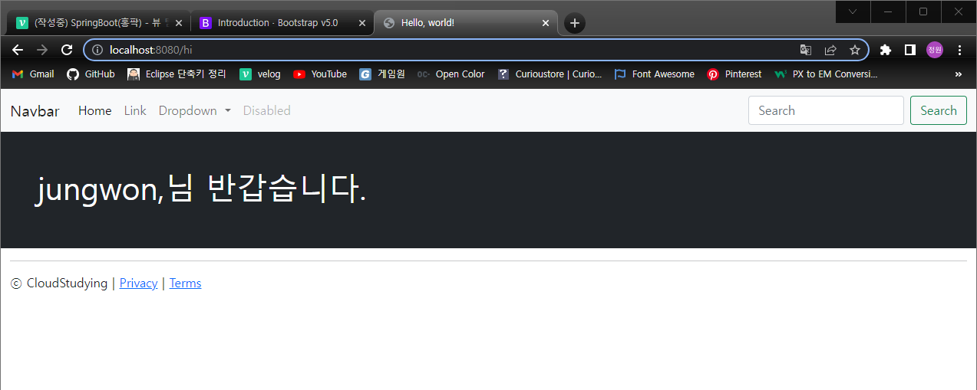

**header / footer 분리하기**

templates - layouts 폴더안에 header,footer 파일 분리  
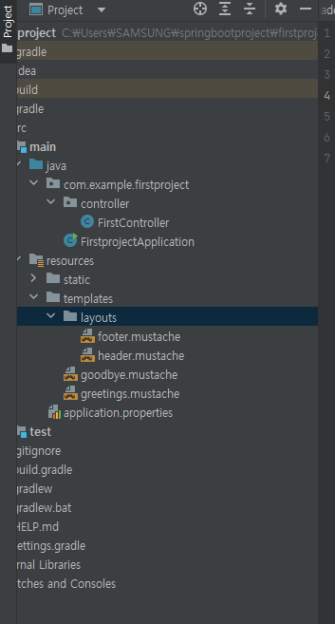

**header.mostache**

본문 위쪽으로 다 추가하기

<!doctype html>

<html lang="en">

<head>

<meta charset="utf-8">

<meta name="viewport" content="width=device-width, initial-scale=1">

<link href="https://cdn.jsdelivr.net/npm/bootstrap@5.0.2/dist/css/bootstrap.min.css" rel="stylesheet" integrity="sha384-EVSTQN3/azprG1Anm3QDgpJLIm9Nao0Yz1ztcQTwFspd3yD65VohhpuuCOmLASjC" crossorigin="anonymous">

<title>Hello, world!</title>

</head>

<body>

<nav class="navbar navbar-expand-lg navbar-light bg-light">

<div class="container-fluid">

<a class="navbar-brand" href="#">Navbar</a>

<button class="navbar-toggler" type="button" data-bs-toggle="collapse" data-bs-target="#navbarSupportedContent" aria-controls="navbarSupportedContent" aria-expanded="false" aria-label="Toggle navigation">

<span class="navbar-toggler-icon"></span>

</button>

<div class="collapse navbar-collapse" id="navbarSupportedContent">

<ul class="navbar-nav me-auto mb-2 mb-lg-0">

<li class="nav-item">

<a class="nav-link active" aria-current="page" href="#">Home</a>

</li>

<li class="nav-item">

<a class="nav-link" href="#">Link</a>

</li>

<li class="nav-item dropdown">

<a class="nav-link dropdown-toggle" href="#" id="navbarDropdown" role="button" data-bs-toggle="dropdown" aria-expanded="false">

Dropdown

</a>

<ul class="dropdown-menu" aria-labelledby="navbarDropdown">

<li><a class="dropdown-item" href="#">Action</a></li>

<li><a class="dropdown-item" href="#">Another action</a></li>

<li><hr class="dropdown-divider"></li>

<li><a class="dropdown-item" href="#">Something else here</a></li>

</ul>

</li>

<li class="nav-item">

<a class="nav-link disabled" href="#" tabindex="-1" aria-disabled="true">Disabled</a>

</li>

</ul>

<form class="d-flex">

<input class="form-control me-2" type="search" placeholder="Search" aria-label="Search">

<button class="btn btn-outline-success" type="submit">Search</button>

</form>

</div>

</div>

</nav>

**footer.mustache**

<!-- site info -->

<div class="mb-5 container-fluid">

<hr>

<p>ⓒ CloudStudying | <a href="#">Privacy</a> | <a href="#">Terms</a></p>

</div>

<script src="https://cdn.jsdelivr.net/npm/bootstrap@5.0.2/dist/js/bootstrap.bundle.min.js" integrity="sha384-MrcW6ZMFYlzcLA8Nl+NtUVF0sA7MsXsP1UyJoMp4YLEuNSfAP+JcXn/tWtIaxVXM" crossorigin="anonymous"></script>

</body>

</html>

**greetings.mustache**

{{>layouts/header}}  
뷰템플릿 불러올때는 {{ 안에 > 사용  
✨코드가 간결해졌당.

{{>layouts/header}}

<div class="bg-dark text-white p-5">

<h1>{{nickname}}님, 다음에 만나요</h1>

</div>

{{>layouts/footer}}